Documents for Ruby: <https://jekyllrb.com/docs>

1. Install Ruby (<https://jekyllrb.com/docs/installation/windows/> )

Download Ruby: <https://rubyinstaller.org/> , install Ruby with default options.

Explain: Ruby is a programming language, like Python, and it is almost out of date.

Tutorial for Ruby: <https://www.bilibili.com/video/BV1QW411F7rh>

1. Ruby library
2. gems: like **packages** or **library** in python, in Ruby, it is called gems.
3. Gemfile: like **requirements** in python project. Every Ruby project need a Gemfile to tell what gems it needs.
4. Bundler: a gem, used to download or update all Gemfile of a project. It likes **pip** **install -r requirements.txt** in python

It is not necessary to use Bundler to manage project requirement, but it is quite useful.

So, we need to install first by using gem install bundler in the terminal

1. Jekyll: a gem, web page template engine, like Jinja2 (the engine used in Flask) in python. Eg: give {{ time }}, Jekyll will substitute it to the real time.

So, we need to install then by using gem install jekyll in the terminal

1. Create Gemfile

Enter an empty the directory, open cmd, type bundle init, use bundler to generate Gemfile. Edit Gemfile in text editor and add Jekyll as a dependency library: gem "jekyll"

1. Create your web pages, for more information: <https://jekyllrb.com/docs/step-by-step/01-setup/>
2. Build the web template

generate a static web site: jekyll build or bundle exec jekyll serve, and it outputs a static site to a directory called _site

For the project without extra enRun the server: jekyll serve, it will be shown at <http://localhost:4000>

1. Problems and solutions
2. Problem: You have already activated i18n 1.10.0, but your Gemfile requires i18n 0.9.5.

Solution: version is not match, use bundle exec jekyll serve instead to active the server

1. Problem: cannot load such file – webrick

Solution, webrick (a gem) is not included automatically in the new version, you should add it manually by bundle add webrick in the terminal, or add this dependency information in Gemfile gem "webrick", "~> 1.7"

1. Problem:

Solution: update the bundle by bundle update

Template: MrGreen-JekyllTheme

1. Disable some function
   1. \_config.yml

Set base url (line 10), and path to this site (line 14)

* 1. \_data\conf\main.yml

Disable Google font (line 10)

Using site internal javascript (line 5)

Language setting:

default language (line 16)

language list (line 24)

Disable language translation offer box (line 27)

Disable Search (line 65), in \pages\ja\query\search.json, uncomment the "published: false"

Disable Dark color (line 117)

Disable scroll_back_to_top_button (line 148)

Disable side navigation bar footer (line 154)

Disable navigation hover effect (line 172, line 175)

Disable blog and archive button (line 187 to line 188), and disable links button (line 192 to line 193)

Update post icon, from fa-pencil-square-o to fa-cog, use it to show project (line 186), Change Blog name to Projects (\_data\lan9g\en.yml, line 108)

Update project icon to fa-archive, use it to show Archive (line 190), Change Projects name to Courses (\_data\lang\en.yml, line 158)

Change Archive name to Courses (\_data\lang\en.yml, line 145)

Disable hover effect of bottom button (line 215)

Disable creative_commons of copy right (line 240)

Disable cookie consent (line 308)

Update profile image path (line 212), /assets/img/posts/profile.jpg, add a profile named profile.jpg in \pages\assets\img\posts\

Disable mobile app header (line 284)

Disable SEO hreflang (Searching Engine) (line 252)

Disable SEO keywords (line 256)

Disable SEO twitter_card (line 256)

Disable SEO open_graph (line 259)

Disable SEO schema_markup (line 261)

* 1. \_data\conf\other.yml

Disable home new posts (line 5)

Enable email (line 15)

* 1. \_data\owner\en.yml

Enable contacts information on the side navigation bar (line 50), by uncomment at least one item

1. Header
   1. Delete \_includes\default\header\header.html (line 62 to 63)

<meta name="description" content="{{ meta_desc | truncate: 150 }}">

<meta name="robots" content="index, follow">

* 1. Change the Standard icons, keep only:

<link rel="icon" type="image/png" href="{{ site.baseurl }}/assets/img/favicons/favicon.jpg">

Keep favicon.jpg \assets\img\favicons, delete other images

1. Languages and information
   1. \_data\conf\main.yml (line 23)

Change to language_switch_lang_list: [en, cn]

* 1. \_data\lang\en.yml

Change the description (line 170)

* 1. \_data\owner\en.yml

Change the brand (line 5, and line 11)

* 1. \_data\const\contact.yml

Change contact information

1. Home page settings
   1. Change the frontpage pictures in \pages\assets\img\home
   2. Change the frontpage headline in \pages\_data\owner\en.yml (line 16, line 18)
   3. Change the frontpage introduction in \index (line 39), using:

{%- include multi_lng/get-lng-by-url.liquid url = page.url -%}

{%- assign lng = get_lng -%}

<h3 id="hello"> {{ site.data.owner[lng].homepage_title }}</h3>

<p> {{ site.data.owner[lng].homepage_introduction }} </p>

Add extra items in \_data\owner\en.yml at the end of the file:

homepage_title: "Introduction"

homepage_introduction: "Your introduction"

* 1. Change the width of all pages \assets\css\main.scss (line 22)

--main-container-width-limit: 1000px;

1. About page settings
   1. Change the about page subtitle \pages\_data\owner\en.yml (line 22)
   2. Cancel Email and Contact information, \_data\conf\others.yml (line 17, line 19)
   3. Change the about page introduction, in \_layouts\about.md (line 49)

<h3 id="hello"> {{ site.data.owner[lng].aboutpage_title }} </h3>

<p> {{ site.data.owner[lng].aboutpage_introduction }} </p>

Add extra items in \_data\owner\en.yml at the end of the file:

aboutpage_title: "Resume"

aboutpage_introduction: "Something, Something, Something"

* 1. Change the about page profile \assets\img\about\about.jpg
  2. Change the margin of About page in

\assets\_scss\about\about-style.scss (line 8 to line 10)

margin-top: 0%;

margin-left: 0%;

margin-right: 5%;

* 1. Change the margin of image in \assets\_scss\about\about-style.scss (line 8 to line 23), add:

margin: 5%;

1. Courses Page Settings
   1. Delete \_layouts\projects.md (from line 21 to line 34)

<div class="multipurpose-container project-heading-container" {{project_container_style}}>

{%- assign color_style = nil -%}

{%- if project_data.main.text_color -%}

{%- capture color_style -%} style="color:{{ project_data.main.text_color }};" {%-endcapture-%}

{%- endif %}

<h1 {{ color_style }}>{{ project_data.main.header | default: "Projects" }}</h1>

<p {{ color_style }}>{{ project_data.main.info | default: "No data, check page_data in [language]/tabs/projects.md front matter or _data/content/projects/[language].yml" }}</p>

<div class="multipurpose-button-wrapper">

{% for category in project_data.category %}

<a href="#{{ category.type }}" role="button" class="multipurpose-button project-buttons" style="background-color:{{ category.color }};">{{ category.title }}</a>

{% endfor %}

</div>

</div>

* 1. Delete \_layouts\projects.md (line 45, after delete the lines above)

<p class="category">#{{ category.title }}</p>

Change it to:

{% if list.date -%}

<div class="meta-container">

<p class="date"><i class="fa fa-calendar fa-fw" aria-hidden="true"></i>&nbsp;

{{ list.date | date: site.data.lang[lng].date.long }}

{% if list.to_date -%}

to {{ list.to_date | date: site.data.lang[lng].date.long }}

{%- endif %}

</p>

</div>

{%- endif %}

Change the width of date, in \assets\_scss\projects\project-container.scss (line 124) width: 65%;

It will become:



* 1. Add a to_date labels in \_data\content\projects\en.yml

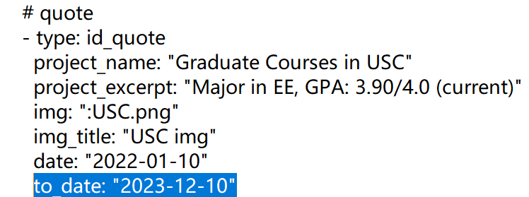

* 1. Decrease the margin of the Course page in \assets\_scss\projects\project-container.scss (line 30 and 31)

margin-left: 0;

margin-right: 0;

* 1. Change the image margin of the Course page in \assets\_scss\projects\project-container.scss (line 47), add margin: 5%;

1. Delete ja Language and add new Language
   1. Delete ja in \_data\conf\main.yml (line 23), and add cn in the list
   2. Copy file in \_data\content\projects\en.yml, \_data\lang\en.yml, \_data\owner \en.yml, name it cn.yml. Translate English items into Chinese items.
   3. Rename \ja to \cn, and change all Japanese items into Chinese items.
2. Projects
   1. Disable comments function \_data\conf\posts.yml (line 139) enable: false
   2. Use number as pagination, posts.yml (line 119) pager_navigation_post: page_numbers
   3. Disable share button, posts.yml (line 100)
   4. Disable hover effect of the filter, posts.yml (line 64), uncomment it.
   5. Disable read time tab in



In \_includes\post_common\post-info-html.html, uncomment line 13

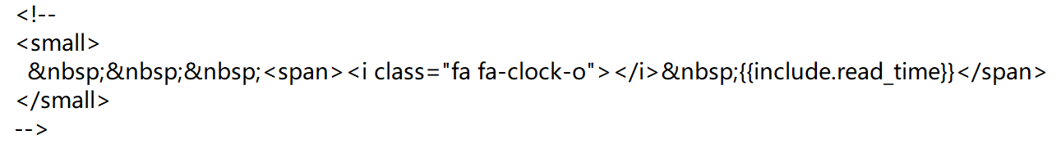

It will become



* 1. Set a margin in the project list in \_includes\post-list\post-thumbnail-html.html (line 9)

style="background-image:url('{{include.image}}');{{include.display}};margin:1%"

* 1. Cancel the left margin of the filter tab in \assets\_scss\post-list\upside-down-tabs.scss (line 37), uncomment it.

1. Finally, fine tune some detail:
   1. \_site\tabs\projects.html and \_site\cn\tabs\projects.html and

Merge two column (because the form is generate automatically, it does not support merge operation)

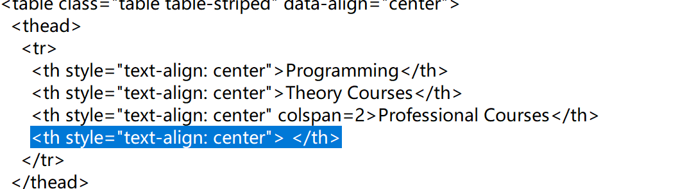

Add colspan=2 attribute, and delete the highlight line

Problems:

1. Delete ja in \_data\conf\main.yml (line 23) will cause problems below:

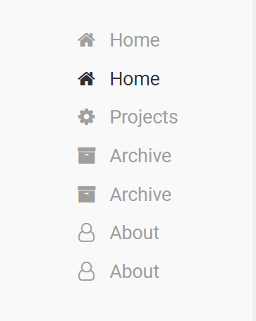

Because:

1. \_layouts\home.md include \_layouts\default.md
2. \_layouts\default.md include \_includes\default\nav\navigation-side-nav.html
3. \_includes\default\nav\navigation-side-nav.html include navigation-buttons.html
4. \_includes\default\nav\navigation-buttons.html use all of the pages in the website (include key pages and normal pages, and use where_exp to filter all normal pages), and pick all the pages satisfy current language by line 7, which include multi_lng/get-pages-by-lng.liquid
5. multi_lng/get-pages-by-lng.liquid include multi_lng/get-lng-by-url.liquid to get current language, and return all pages satisfy current language
6. multi_lng/get-lng-by-url.liquid used to get current language. If this step goes wrong and distinguish ja pages as en pages, that would cause the problems. In this file, if ja in data.conf.main.language_switch_lang_list, then pages in /ja directory would be picked up successfully, otherwise, pages in /ja would be counted as default language en.
7. In this way, Jekyll should not include /ja, we rename /ja to /cn